**COURSE MAP:**

**Lesson 0 - Introduction**

**Lesson 1 - Use of functions**

**Lesson 2 - Use of classes**

**Lesson 3 - Making classes**

**Lesson 1**

Using this code we will be able to open a website through python:

webbrowser.open(“http://www.google.com”)

Documentation: <https://docs.python.org/2/library/webbrowser.html>

import time

import webbrowser

Rename file:

os.rename()

<https://docs.python.org/2/library/os.html>

Translatefunction:

<https://stackoverflow.com/questions/41708770/translate-function-in-python-3>

Documentation for the module os:

<https://docs.python.org/2/library/os.html>

**Lesson 3**

You can think of the class as of a blueprint of the buidling. It has different pieces of information about the building e.g number of rooms, type. Using this blueprint we can build different types of buildings e.g office building, apartment building.

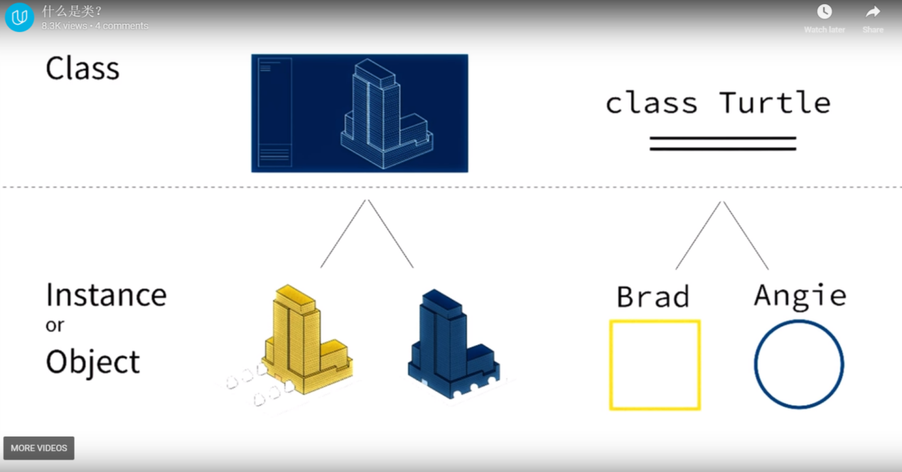

Lesson 5:

Build in python functions:

https://docs.python.org/2/library/functions.html

Urllib is a module in python and def urlopen is a function inside it.

Documentation:

<https://docs.python.org/2/library/urllib.html>

Google style guide for python:

<https://google.github.io/styleguide/pyguide.html>

Lesson 6:

**Lesson 7:**

Class variables

Instance variables

If value of the variable is constant Google style says to use all caps in the name of the variable.

__doc__

Import turtle

turtle.Turtle.__doc__ (it will show documentation for class Turtle)=

Print(media.Movie.__doc__)

Other predefined variables:

__name__

__module__

Reference: http://www2.lib.uchicago.edu/keith/courses/python/class/5/

In Python method overriding occurs simply defining in the child class a method with the same name of a method in the parent class. When you define a method in the object you make this latter able to satisfy that method call, so the implementations of its ancestors do not come in play